# Our Commentary about the NHSS

Abstract

The COVID-19 epidemic in 2020 has greatly awakened people's attention to NHSS(National Health Service System). While NHSS is dominated by politics and economy, it also has a certain reaction to politics and economy, and this reaction is particularly significant during the epidemic. Therefore, it is of great practical significance to study how to reasonably evaluate the NHSS and make beneficial reforms to the NHSS accordingly. We use Trump and Biden’s debates on COVID-19 and US NHSS reforms as the problem background to explore the establishment of appropriate mathematical models for scientific and reasonable evaluation of NHSS, in order to compare the NHSS of China and the United States and the United States. The presidential candidate evaluated the NHSS reform strategy and gave corresponding suggestions.

We first selected five evaluation indicators: life expectancy, healthcare coverage on long-term/fatal disease, healthcare coverage rate, percentage of GDP spent on health care, the capability of adapting health emergency. Then, we normalized the data found and tested the validity of the indicators by comparing horizontally and vertically.

Finally, by establishing an analytic hierarchy model, we use MALTAB to obtain the weight  of each indicator and construct the NHSS comprehensive evaluation model from this.

After completing the construction of the model, we extracted Trump and Biden’s NHSS reform policies related to the indicators we selected, combined with the laws of existing data to quantify the qualitative conclusions, and used polynomial fitting methods to predict Trump He and Biden’s policies will affect these indicators in the future and use the evaluation model to score them. The scoring results show that in the long run, Biden's policy is more beneficial to reforming NHSS.

Then score the NHSS of China and the United States. The results show that China's NHSS is better and has greater development potential at this stage. At the same time, we also scored a single item of the NHSS's ability to respond to emergency health events in the two countries. The results show that China's NHSS is more suitable for responding to the COVID-19 crisis.

After that, we began to consider the reform of China's NHSS system. We take the maximization of the comprehensive evaluation score as the objective function, and take the total score unchanged and the single index within two consecutive years of not more than ±5% as the constraint conditions, establish an optimization model, and solve it.

Finally, using the information we have, we prepared a report for American voters to tell ordinary voters that Biden’s strategy is more acceptable.

Key word: **NHSS analytic hierarchy model polynomial fitting**

### Contents

1. Introduction ------------------------------------------------------------------------------ 2
   1. Background
   2. Problem Restatement
2. Assumptions and Justification --------------------------------------------------------- 2
3. Notations ---------------------------------------------------------------------------------- 2
4. Model Construction --------------------------------------------------------------------- 3

4.1 Problem Analysis

4.2 Model Design

4.2 Solution for Part I

5. The Strategies Biden and Trump for reforming NHSS of USA -------------------- 9

5.1 Problem Analysis

5.2 Model Establishment

5.3 Model Solution

5.4 Evaluation of Both Strategies

6. The comparison of the NHSS of United States and that of China ---------------- 12

6.1 Problem Analysis

6.2 Model Solution

7. China's NHSS Reform Direction ----------------------------------------------------- 15

7.1 Problem Analysis

7.2 Optimization Model Establishment

7.3 Our suggestions

8. Model Analysis ------------------------------------------------------------------------- 16

8.1 Advantages

8.2 Disadvantages

8.3 Sensitivity

9. A Report for the American Voters ---------------------------------------------------- 18

Reference ----------------------------------------------------------------------------------- 19

Appendix ----------------------------------------------------------------------------------- 20

### 1 introduction

#### Background

In recent years, with the development of science and technology, people's living standards have been continuously improved, and higher requirements have been placed on the health care and medical industries. In response to this growing demand, countries around the world have established national medical systems. As a form of social welfare, medical security has been deeply rooted in the hearts of the people and has been widely adopted.

But many problems also follow. Expensive medical services have become a burden on people. While enjoying good medical services, people are also worried about the uneven distribution of medical resources and the low utilization rate of funds in the medical system. In addition, the recent outbreak of COVID-19 has also aroused people's attention to the ability of the medical system to respond to emergencies. So how to evaluate the effectiveness and quality of a national health service system? What indicators should we adopt to measure it? What is the relationship between these indicators? Does our model apply to countries with different situations?

#### 1.2 Restatement

**Part I:** Choose some indicators to measure the effectiveness and quality of NHSS, and prove these indicators useful and collectable. After that, make use of these indicators to build a model for measuring.

**Part II**: Compare Donald Trump and Joe Biden's strategies on reforming NHSS with the aid of the indicators we chose.

**Part III**: Compare the effectiveness and quality of NHSS in PRC and US with the aid of the indicators we chose. Analyze the results obtained in order to prove the validity of our model.

**Part IV**: Construct and test some reform plans of China's NHSS, use predictive models to test these plans, and select feasible plans to make recommendations for China's reforms.

**Part V**: Explain the advantages and disadvantages of Donald Trump and Joe Biden's strategies on reforming NHSS to voters in plain language.

### 2 Assumption and Justification

1. Nationals in each country are equal in expenditure on medical costs and enjoyment of health services;

2. During the four-year term of each U.S. president, his policy on NHSS is stable, and the change of indicators can be regarded as linear;

3. Each indicator can be directly and independently affected by reform policies, and the indicators are independent of each other.

### 3 Notations

|  |  |
| --- | --- |
| symbol | Definition |
|  | the Quantitative Functions of NHSS Evaluation Indicators |
|  | the quantitative function of healthcare coverage on long-term/fatal disease |
|  | the quantification function of medical insurance coverage |
|  | the quantitative function of medical expenditure/GDP |
|  | the quantitative function of the ability to respond to emergencies |
| In which | Cancer, AIDS, diabetes, hypertension, rare disease coverage function during $y$ |
|  | Medicare coverage in year $y$ |
|  | The rate of medical expenditure/GDP during year $y$ |
| $$r\left(y\right)$$ | Death rate from major infectious diseases in year $y$ |
| $$\overline{ω}$$ | Combined weight vector |
| In which | The weight of life expectancy, critical illness medical insurance capacity, medical expenditure/Gross national GDP, ability to respond to emergencies, medical insurance coverage |
|  | Index score vector |
| $$Z$$ | Final score |

### 4 Model Construction

#### 4.1 Problem Analysis

There are 4 main requirement in Part I:

1. Select indicators to evaluate the effectiveness of NHSS;
2. Prove the validity of indicators;
3. show that our indicators are collectable and convenient to use;
4. Through comprehensive consideration of various indicators, obtain a comprehensive evaluation model for scoring NHSS.

**The selection of indicators**

We firstly take personal satisfaction, fair Service, social resource consumption as [primordial](D:/Dict/8.9.3.0/resultui/html/index.html" \l "/javascript:;) criterion. With internationally accepted indicators for evaluating health service systems taken into account, we choose percentage of GDP spent on health care, life expectancy, healthcare coverage rate and healthcare coverage on long-term/fatal disease as our metrics for consideration. However, considering that the above indicators are biased towards the evaluation of the quality of NHSS in the general period and cannot reflect the reliability of a country's health service system in a special period, we add the the capability of adapting health emergency as the fifth indicator.

**The proof of the validity of indicators**

Considering that the function of the indicator is to measure the service level of the system, and the measurement requires a standard, so four relatively representative countries——the United States, China, the United Kingdom, and Japan are chosen for comparison. In this way, the effectiveness of indicators in reflecting differences between countries (different individuals) could be tested with the aid of the horizontal comparison ; and the effectiveness of indicators in reflecting changes within a country (at different times) could be tested by comparing the conditions in different years within a single country.

**The [availability](D:/Dict/8.9.3.0/resultui/html/index.html" \l "/javascript:;) of our indicators**

We construct different scoring functions for each indicator, and standardize (or normalize) the scores obtained to obtain a quantitative measurement system for each indicator; regarding data acquisition, this article attaches data samples and sources to the appendix.

#### 4.2 Model Design

**1. Selection of NHSS Evaluation Indicators:**

(1) From the perspective of personal satisfaction, we select the following two indicators: **average life expectancy** and **healthcare coverage on fatal disease**. Among them, critical illness medical insurance capability refers to the medical insurance coverage rate for cancer, AIDS, diabetes, hypertension, and rare diseases.

(2) From the perspective of service fairness, we select the following 1 indicator: **medical** **insurance coverage**;

(3) From the perspective of of social resource consumption, we select the following 1 indicator: **medical expenditure /national GDP**;

(4) From the perspective of system reliability in emergency, we select the following 1 indicator: **the capability of adapting health emergency**.

**2. Proof of Validity**

We select the relevant data of the United States, China, the United Kingdom, and Japan from 2000 to 2017 for horizontal and vertical comparisons, and draw the corresponding charts as follows.

It can be intuitively found that the selected indicators reflect the differences between countries and the differences in the same country during different periods. On the other hand, the selected indicators have a strong representativeness of the level of health services. Therefore, the selected indicators have a better effectiveness in evaluating the quality of NHSS.

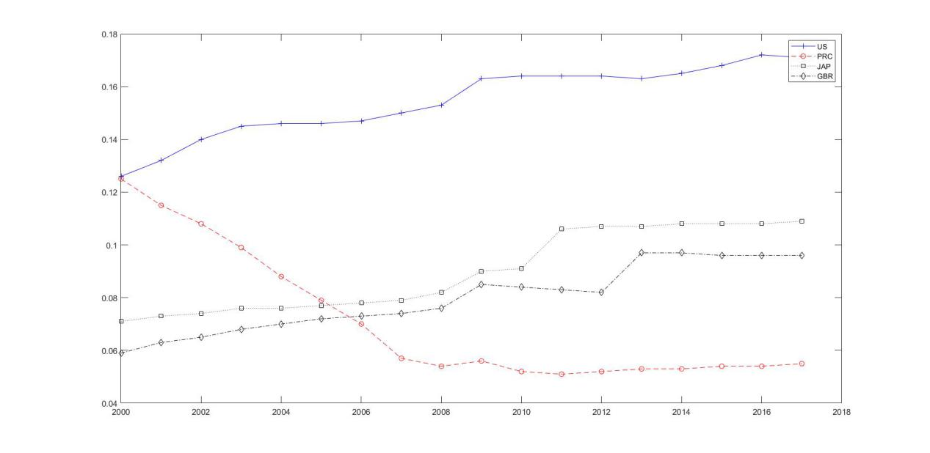

Figure 1:percentage of GDP spent on health care

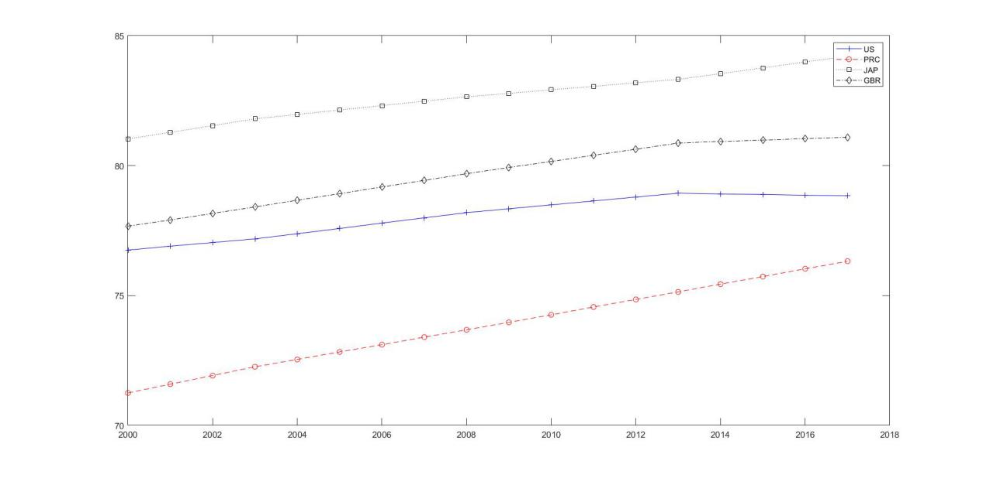

Figure 2:life expectancy

1. **the Quantitative Functions of NHSS Evaluation Indicators:**

**•Construction of the quantitative function of the life expectancy:**

Considering that the higher the average life expectancy, the higher the national’s satisfaction with the health service system, the quantitative function of this indicator should be positively correlated with the independent variable (life expectancy); on the other hand, the higher the average life expectancy, the higher the life expectancy The greater the investment, the more superior the quality of the health service system can be achieved, so a nonlinear exponential function is constructed for scoring.

In this paper, we take the minimum value of the average life expectancy data of 4 countries from 2000 to 2017 to make the function value 0, and the maximum value to make the function value 100, and construct the quantitative function of the average life expectancy index based on the following equation:



In which y represent the life expectancy and c as well as K are constant.

**•Construction of the quantitative function of coverage on long-term/fatal disease:**

For the selected 5 major diseases, if a country covers the disease in a certain year by its medical insurance, we take $x_{i}\left(y\right)=20$,other wise $x_{i}\left(y\right)=0$,int which $i=1,2,3,4,5$,representing cancer, AIDS, diabetes, hypertension, and rare diseases respectively. Then the quantitative function of healthcare coverage on long-term/fatal disease is:



**•Construction of the quantification function of medical insurance coverage:**

It is widely accepted that achieving 100% medical insurance coverage is an ideal goal that each country’s NHSS should pursue, and regard it as the highest scoring standard for scoring medical insurance coverage. Therefore, the quantitative function of the medical insurance coverage index is as follows:



In which  is the healthcare coverage rate in year of a country.

**•Construction of the quantitative function of medical expenditure/GDP:**

When national medical expenditure/gross national GDP (including personal expenditure and public expenditure) is lower than a certain threshold, the lower the value, the greater the country’s lack of medical investment, and the less effective its NHSS ; And when the total national medical expenditure in total national GDP is higher than this threshold, the lower its value, the more generally it can reflect the efficiency of its NHSS, that is, its NHSS has a higher effectiveness. In order to reasonably simplify the complexity of the model, this article chooses to express the quantitative function of medical expenditure/GNP in the form of a quadratic function as follows:



In which a,b are constant, b is the threshold mentioned [hereinbefore](D:/Dict/8.9.3.0/resultui/html/index.html" \l "/javascript:;). when , assumes its maximum 100. and its minimum is 0.

**•The construction of the quantitative function of the ability to respond to emergencies:**

We use the death rate of infected persons in the face of more serious infectious diseases in various countries as the basic data to construct the quantitative function of the ability to respond to emergency health events. The time span is 2000-2017. For a country that has not encountered a major infectious disease event in a certain year, this paper uses spline interpolation to preprocess the data.

The following gives the quantitative function of the ability to respond to emergency health events:



In which $r_{max}$ is the highest of all mortality, and $r_{min}$ is the lowest, $r\left(y\right)$ is the death rate of a country in year .

1. **Establishment of NHSS comprehensive evaluation model:**

Using the Analytic Hierarchy Model, the comprehensive evaluation of NHSS is used as the target layer, the above-mentioned four aspects of personal satisfaction are used as the criterion layer, and the selected indicators are used as the plan layer, and the result diagram of the layer analysis is established as shown in the figure:

Figure 3: NHSS comprehensive assessment hierarchy

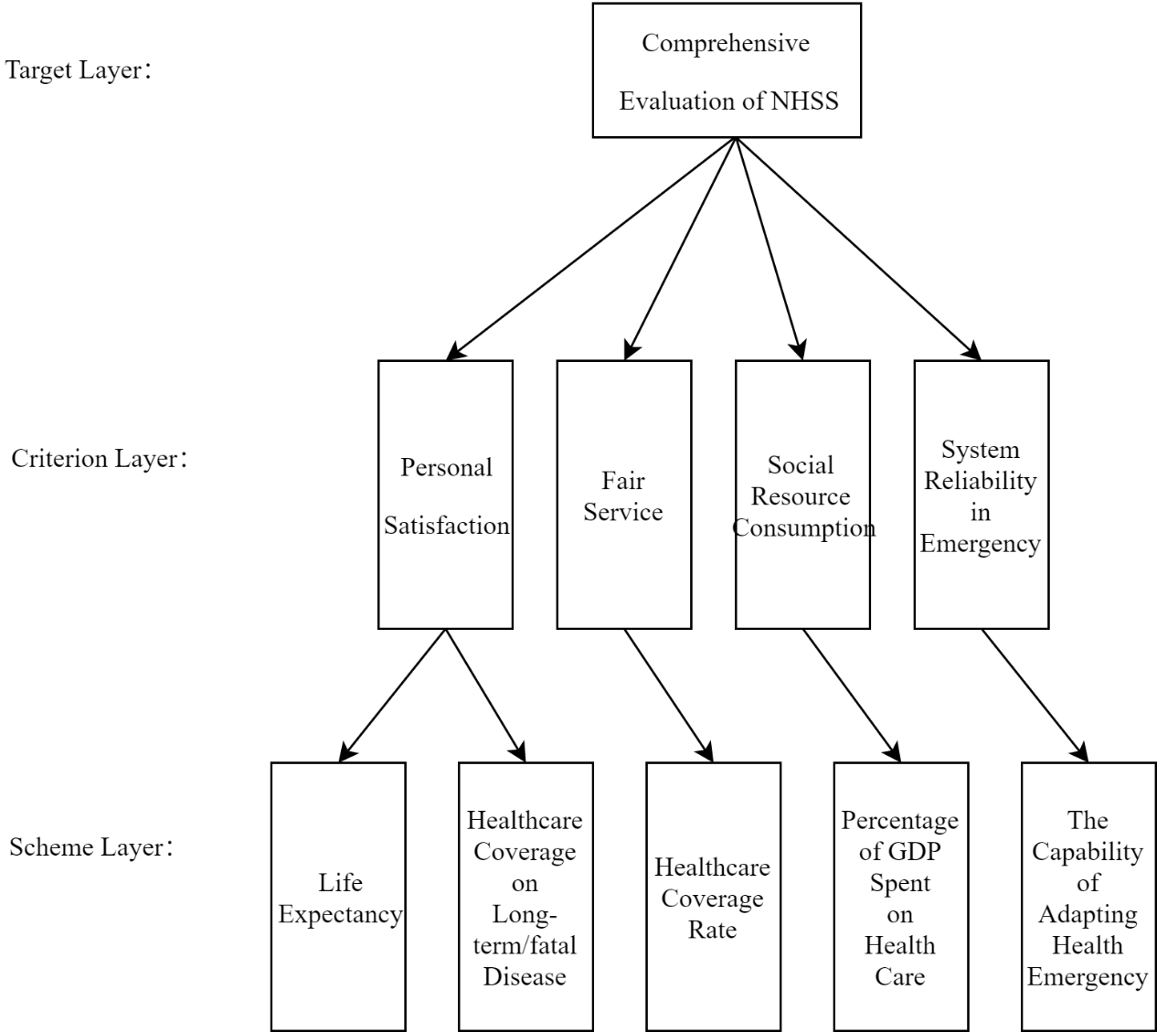

The importance of each indicator is ranked from large to small: Average life expectancy, critical illness medical insurance capacity, medical expenditure/Gross national GDP, ability to respond to emergencies, medical insurance coverage. And construct the pairwise judgment matrix accordingly. (See the appendix for the pairwise judgment matrix) The final combined weight vector is obtained by calculation and after the consistency check of the judgment matrix:

$$\overline{ω}=\left[ω_{1}{,ω}_{2}{,ω}_{3},ω_{4},ω_{5}\right]$$

In which $ω_{i}$， $i=1,2,3,4,5$ respectively represent the weights of the average life expectancy, critical illness medical insurance capacity, medical insurance coverage rate, medical expenditure/gross national GDP, and ability to respond to emergency health events. Let the index score vector be:



The final NHSS comprehensive evaluation model is:



In which represent the final score of NHSS.

#### 4.3 Solution of Part I

**1. Determination of parameters**

**•Solving the quantitative function parameters of the life expectancy:**

According to the data obtained, the average life expectancy of China in 2000 was 71.25 years as the minimum life expectancy of all people, and the average life expectancy of Japan in 2017 was 84.21 years as the maximum life expectancy of all people. Substitute them into the equation, we have:

 in which 

**• Solving the parameters of the medical expenditure/GDP function:**

By fitting the quadratic function curve, this paper obtains a good approximation of the parameters:



1. **Consistency check**

According to a certain criterion, calculate the relative weight of each scheme, that is, rank order, and pass the consistency test. Define the consistency index as CI

$$CI=\frac{λ-n}{n-1}$$

In which is the largest characteristic root of $λ$, and $n$ is the order of the matrix.The data of the random consistency index RI is shown in the following table:

|  |  |  |  |  |  |  |  |  |  |  |  |
| --- | --- | --- | --- | --- | --- | --- | --- | --- | --- | --- | --- |
| N | 1 | 2 | 3 | 4 | 5 | 6 | 7 | 8 | 9 | 10 | 11 |
| RI | 0 | 0 | 0.52 | 0.89 | 1.12 | 1.26 | 1.36 | 1.41 | 1.46 | 1.49 | 1.52 |

Concordance ratio CR：

$$CR=\frac{CI}{RI}$$

When the general consistency ratio CR<0.1, the test passes, and the normalized feature vector can be used as the weight vector.Using the above algorithm, we get the consistency of the index weight. (Refer to appendix for specific data)

The final weight of each indicator is:



### 5. The Strategies Biden and Trump for reforming NHSS of USA

#### 5.1 Problem Analysis

The medical service in the United States is known for its high professionalism and high technology content, but its high service prices are also daunting for many people. The predecessor of the United States, Obama, formulated and implemented the famous and controversial Obamacare reform,which is also called Affordable Care Act (ACA, or PPACA), and the current President Trump has carried out drastic reforms of Obamacare, which has also caused great controversy. The current two presidential candidates, Biden and Trump, have proposed different strategies on reforming NHSS in response to the issue of the NHSS. In order to evaluate the advantages and disadvantages of Donald Trump and Joe Biden's strategies on reforming NHSS. First of all, we analyze its policies, find out the influence trend of these policies on the factors we choose, use this trend to fit the existing data in previous years, and use the function obtained by the fit to find the expected values of various factors during the future presidential term, and these expected values need to be substituted into our model to find the effectiveness and quality of these strategies.

We checked the strategies and opinions of Biden, Trump and their team by listening several public speeches and read various newspapers. They showed their inclination on various aspects of NHSS reform, specific policies, which would be shown in the appendix with their literature quotations. The influence of each factor we selected will be shown in the following table:

|  |  |  |
| --- | --- | --- |
| INDICATOR | TRUMP | BIDEN |
| percentage of GDP spent on health care | By reducing medical insurance coverage items and population, improving the status of state governments and private companies in medical insurance operations, and reducing medical expenditures. | Under the premise of protecting the rights and interests of disadvantaged groups, some provisions that Obama should change should be amended to ； avoid rapid growth in spending. |
| life expectancy | Vulnerable groups have less protection. | Vulnerable groups have relatively more protection. |
| Healthcare coverage rate | Lower. | relatively bigger. |
| coverage on long-term/ fatal disease | Insurance companies have greater choice of users, which is not conducive to long-term/ fatal disease coverage. | Support legislation to ensure coverage of long-term/ fatal diseases to some extent. |
| the capability of adapting health emergency | Let more commercial insurance companies enter the market and improve the market’s ability to respond to shocks. | Strengthening the country's control over the medical system will enable the country to better plan the arrangements of medical resources which can also improve the ability to respond to shocks. |

#### 5.2 Model Establishment

By analyzing the policies of Trump and Biden and combining existing data, we found that the reform policies of Trump and Biden on NHSS are more obvious in terms of finances. Therefore, in the following, we will take the proportion of medical expenditure in national GDP as an example to illustrate the modeling ideas and process. As for other indicators, since a similar modeling method is adopted, we will not repeat them here, and only show the results in the solution section.

First, give a line chart of US medical expenditure/national GDP from 2000 to 2017:

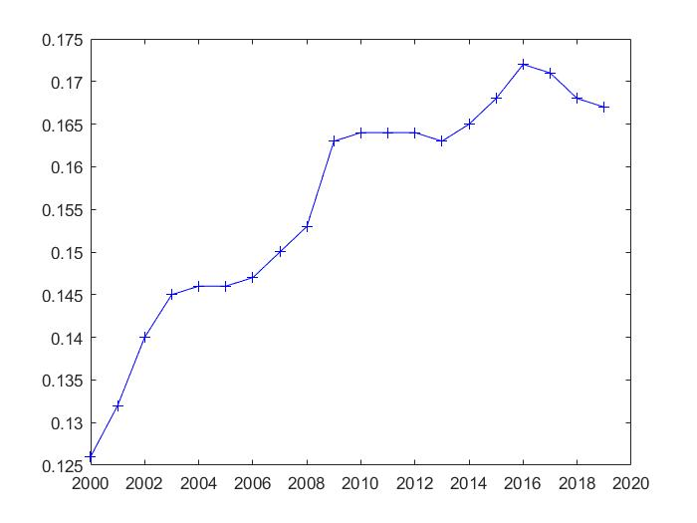

Figure 4: US medical expenditure/national GDP from 2000 to 2017

Through observation, it can be found that during the four-year term of each president, the change rule of the broken line in this interval tends to be linear. When we separately extract the data from Obama's 2012-2016 tenure and Trump's tenure to draw a line graph, the linearity becomes particularly significant.

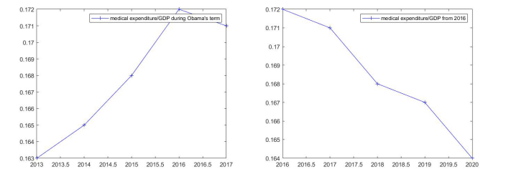

Figure 6: the data from Trump's tenure, 2016-2020

Figure 5: the data from Obama's 2012-2016 tenure

5.3 Model Solution

5.4 Evaluation of Both Strategies

Based on this, we consider using a polynomial fitting method to predict the impact of Trump and Biden’s policies on the future, and determine the degree of fitting to be 1, and obtain the following fitting equation:

$$S_{}\left(y\right)=α(y-2017)+β$$

#### 5.3 Model Solution

It can be seen from the policies of Trump and Biden that Trump is totally opposed to ACA, while Biden supports the retention of some ACA policies, but also agrees to reform some of the policies. Therefore, we choose to use the slope of the 2016-2017 broken line segment in the line chart as the parameter to predict the impact of Trump’s policy; choose to use the slope of the 2013-2016 broken line segment in the line chart after the linear approximation as the Trump policy The parameters that affect the prediction. Because the forecasts for both are based on 2018 as the starting point, the value selection is 2017 data.

Accordingly, the following two fitting results are obtained. Fitting function under the influence of Trump policy:



Fitting function under the influence of Biden policy:



#### 5.4 Evaluation of Both Strategies

Using part I and the method described above, the fitting curve was obtained, and the expenditure/national GDP in the United States in the next few years was predicted with reference to other factors. The parameters are as follows:



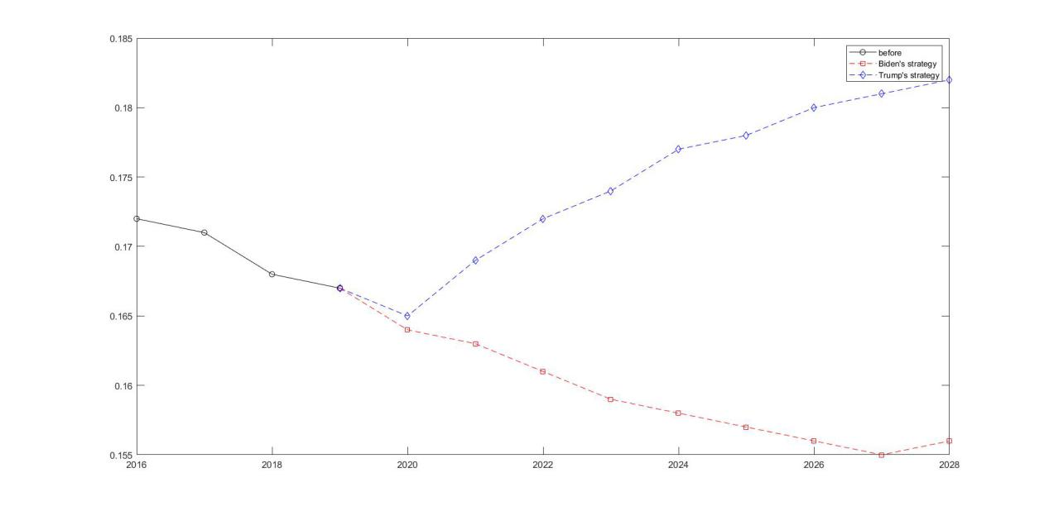

Figure 7: the expenditure/national GDP in the United States in the next few years(assumption)

And the result are shown in the following figure:

By adopting similar methods, we can also obtain the predicted values of other indicators. In order to effectively compare the reform plans of Trump and Biden, we can take 2024 and 2028 as the test targets. The strategies of the two candidates in 2024 and 2028 are shown in the following figure:

 

 

Using the method in Part I, the final scores of the two candidates are as follows:

|  |  |  |
| --- | --- | --- |
| year | Trump | Biden |
| 2024 | 55.01716 | 53.48032 |
| 2028 | 54.50989 | 55.01777 |

Although the scores of the two candidates are not much different in the end, some clues can still be seen. The Republican Trump's plan has obtained good scores in the early stage by reducing expenses, but this short-term structural reform cannot be fundamental. The sexual improvement system is also not conducive to the protection of the medical rights of the citizens, especially the disadvantaged groups. Although the Democrat **Biden’s plan** was initially expensive, it was objectively conducive to the long-term development and planning of NHSS, and to a certain extent took care of the interests of disadvantaged groups in the United States. If Biden and subsequent governments can continue to promote the reform of NHSS socialization, continuously improve the operational efficiency of NHSS, and finally get a powerful and efficient NHSS as Japan, then this will be the best foreseeable result.

### 6. The comparison of the NHSS of United States and that of China

#### 6.1 Problem Analysis

Question 3 is divided into four levels of requirements:

1. Use the indicators in the model established in the first question and the functional calculation model summarized by reasonable mathematical methods to calculate the scores of various aspects. To comprehensively evaluate and examine the NHSS of China and the United States;
2. Compare the comprehensive aspects of the NHSS of China and the United States through the quantitative scores in the first question, and determine which of the two is more reasonable;
3. Combination the quantitative values of the indicators in the model in this article are used to judge which of the two NHSS is more suitable for responding to the COVID-19 crisis;
4. The data found in the literature is used to judge whether the results given in the third question are reasonable, valid, conform to the general trend of the data, and explain the reasons for the results according to the various factors of the model.

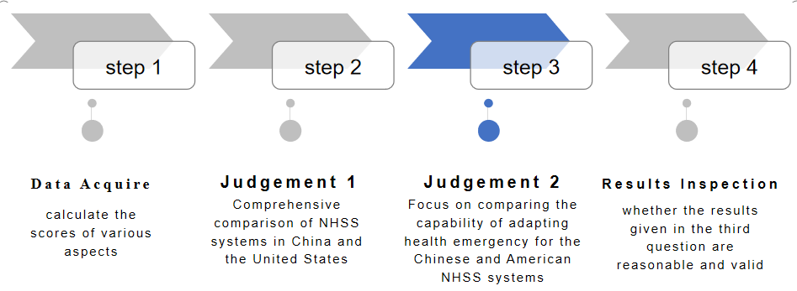

#### 6.2 Model Solution

**1.The comparison of the NHSS of United States and that of China**

**Type**

China Medical Insurance focuses on government medical insurance, and is committed to popularizing all citizens, so that every citizen can enjoy the preferential policies brought by the government, and the overall development is in a good direction;

US medical insurance is divided into private medical insurance and government medical insurance. Due to the political system, the gap between the rich and the poor in the United States is huge. Many rich people will choose private high-standard medical insurance, while ordinary people can only choose the government’s poorer. The overall trend of medical insurance is still developing towards polarization;

**Coverage**

The coverage of China's medical insurance is increasing year by year, and the increase is obvious. So far,the coverage rate gets to 95%, which reflects the efficiency of the Chinese government's medical insurance;

U.S. government medical insurance is also increasing year by year, but the growth rate is slow, and data shows that it is significantly weaker than the growth rate of private medical insurance;

**Effect**

China's government medical insurance has not only increased the coverage rate year by year, but also increased the protection of the national basic medical insurance and reduced the cost of medical treatment;

U.S. government medical insurance, as the government believes that this aspect of losses and the withdrawal of some funds, as the coverage rate increases, basic medical insurance is declining year by year.

**2.Final Score**

By comparing the effective values of the NHSS between China and the United States in the past 15 years (check in the appendix), it can be found that China has achieved a qualitative leap in the effectiveness of NHSS, and it has achieved the United States. Overtaking, China went from 12.14 points in 2000 to 58.85 points in 2017, while the United States scored 41.06 points in 2000 to 50.60 points in 2017. This shows that China's NHSS system is better and has greater development potential.

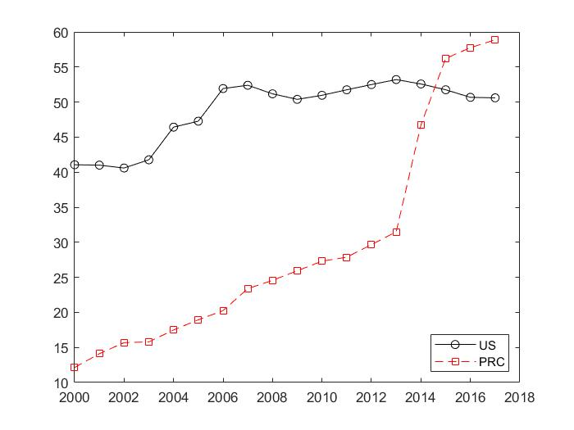

Figure 8: Final Score of US and PRC

1. **The Capability of Adapting Health Emergency**

Through the comparison of NHSS between China and the United States, China has generally developed better in the NHSS system.it can be seen in the capability of adapting health emergency, China is also far higher than the United States in terms of 95 points to 49 points after the quantitative model and indicators. Therefore, it can also be concluded that China's NHSS system is more suitable for responding the crisis of COVID-19.

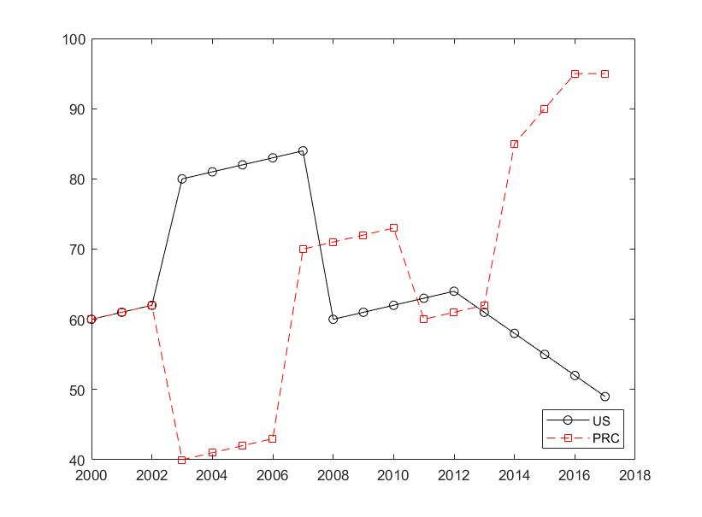

Figure 9: The Capability of Adapting Health Emergency of both NHSS

1. **Conclusion**

After analyzing the data extracted from online literature and websites, we found that the values of various indicators in China's NHSS set by us are developing in a good trend. Use the fitting tool in the mathematical model to predict and analyze the value of the function score in all the indicators. The model predicted by the curve fitting and function approximation method also meets the previous prediction, which shows that we get the conclusion is reasonable and accurate.

### 7. China's NHSS Reform Direction

#### 7.1 Problem Analysis

Problem four is an optimization problem. We are required to build an optimization model to improve China's NHSS so that it can get a higher score in the evaluation model we have previously established. In the optimization model, the objective function is to maximize the comprehensive evaluation scores. Considering that the final reforms are reflected in the changes in the scores of various indicators, we directly use the 2017 China NHSS evaluation total score as the constraint; on the other hand, Considering that the reform should be "moderate" so as to be more easily accepted by the society, we have added a single item score of no more than ±5% as a supplement to the constraints. For the establishment of the prediction model, we also use the method of replacing specific changes with scores for simulation, randomly sampling points within the feasible region of the constraint conditions, and then obtaining more prediction values ​​through fitting, and then substituting the obtained prediction values ​​into the evaluation model Score. Finally, we compare the strategy obtained by the optimization model with the score obtained by the random strategy obtained by simulation to verify the rationality of the optimization model.

#### 7.2 Optimization Model Establishment

According to the above conditions, we constructed the optimization model, the specific formula is as follows:

$$\max{Z=\overline{ω}⋅}S(y)$$

$$s.t.\left\{\begin{aligned}S\left(y\right)=\sum_{i=1}^{5}{S_{i}(y)} \\ \sum_{i=1}^{5}{S_{i}(y)}=\sum_{i=1}^{5}{S_{i}(2017)} \\ 0≤S_{i}\left(y\right)≤100 \\ \left|S_{i}\left(y\right)-S_{i}\left(y-1\right)\right|≤0.05×S_{i}\left(y-1\right)\end{aligned}\right.$$

#### 7.3 Our suggestions

Through comparison, it can be seen that the score obtained by solving the optimization model is higher than the score obtained by randomly sampling points, which proves the rationality of the model.

In addition, we have some other suggestions:

1. Separate treatment and prescription: Patients can buy medicines at any legal pharmacy or hospital after receiving a prescription from a doctor.
2. Separate treatment and inspection: separate the medical examination department of the hospital, establish an independent social physical examination institution (company), and the social physical examination institution will be admitted to the hospital through bidding.
3. Ensure the welfare of frontline medical staff.
4. Use cure rate and satisfaction rate to evaluate and assess medical staff.
5. Adjust the direction of government medical and health investment funds and medical insurance funds.
6. Strictly regulate the hospital's surgical treatment charges and other charges.

Our country is a large country with a population of nearly 1.4 billion. What the people urgently need requires the government to reform and promote. These medical reform proposals may not be appropriate, but there should be many smart reform plans. Is it possible for such a large country? It should not be difficult to choose one or two cities or regions for a trial, because practice is the only criterion for testing truth. I think these medical reform proposals have been thought of by the country a long time ago. It is impossible to lack a scientific plan for reform. What is lacking is the determination to reform hard.

### 8. Model Analysis

#### 8.1 Advantages

①Working out more effective influencing factors and use AHP to design reasonable parameter weights to frame a rough model;

②Using the data basis to quantify all impact factors, and combining weights to score NHSS, with a full score of 100, and comprehensively reflect the overall effect of NHSS through the score;

③The process of quantifying the impact factor index is a process of assigning points to the index, but instead of setting the referenced full score of all the index to 100, it is based on the actual national conditions and the data of the polls to formulate a satisfaction degree. The deviation between the actual value of the two and the referenced value is transformed into a score with 100 as the perfect score using mathematical methods;

④In the forecast trend of the model, by combining the big data and using the function fitting method, the future trend of the NHSS in the four countries in the example can be roughly and effectively predicted.

#### 8.2 Disadvantages

①When using AHP, despite the support of more big data, there are still subjective factors in the conversion between the weights of various indicators;

②This article evaluates the NHSS through the examples of four countries. Therefore, in terms of data, we mainly try to find these four countries. However, there are still some countries that have missing data for some years, and some of the data are distortion, because it is contrary to the perception of normal people;

③There is a lack of objectivity in the process of evaluating the full score referenced value and actual score value of each factor. There is our subjective approach. For example, for the capability of adapting health emergency, we use the infection rate and death rate of the population in the country to calculate the actual score value, which also lacking the theoretical support to prove that the method is feasible and effective;

④When selecting indicators for comprehensive evaluation of NHSS, many small influencing factors are involved, but we have only selected five factors that we recognize with giant impact. This process involves our subjective judgments and lacks [theoretical](D:/%E6%9C%89%E9%81%93Dict/8.9.3.0/resultui/html/index.html" \l "/javascript:;) argumentation.

#### 8.3 Sensitivity

Our model is very suitable for a comprehensive evaluation of the NHSS system. There are many other factors, such as food availability, climate, occupations of citizens, smoking habits, but we found through literature search and data search, these parts are compared with those in this article The five main impact indicators studied have little effect on NHSS. Therefore, in other words, the standard for evaluating NHSS established in this article is feasible and efficient. However, we cannot ignore this part of the impact when we analyze the evaluation system precisely. Therefore, we choose to combine all of these types with the theoretical support of data. Factors are cumbersome and entered into one of the variables in our original model. Because many of the newly added factors have little impact, we checked the literature and finally selected the fluctuation of 3%-7%. We conduct sensitivity analysis and take China’s evaluation as an example to draw a chart:

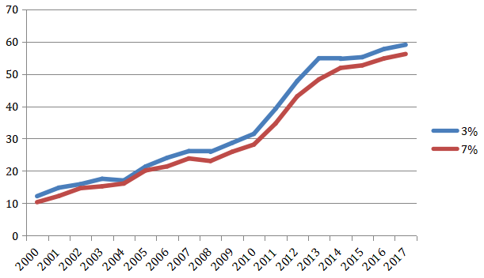

Figure 10: Sensitivity analysis

We put these error influencing factors into the index that was controversial in the original weight setting, and then by changing the proportional weight parameter of this index, we calculated the evaluation score of NHSS under fluctuation based on our model.

### A Report for the American Voters

We have prepared a one page non-technical report for the American voters to demonstrate Biden’s strategy is more acceptable. Here is the report:

Who will provide you a better health care--Trump or Biden?

With the results of the presidential election and the race for control of the Senate still undecided, it's also not entirely clear what will happen to the many healthcare issues facing Congress, the president, and federal agencies. We asked experts to discuss the possibilities under a Trump administration or a Biden administration, and how a Democratic- or Republican-controlled Senate might play out.

**ACA or Lower taxes?**

If President Trump wins re-election, what can Americans expect to see as far as healthcare reform? In fact, Republican lawmakers are anxious about canceling ACA. They have no interest and energy to construct a substitute for ACA. If ACA is officially cancelled, the prices of many prescription drugs will increase. However, Trump's election also means lower taxes. He had promised to cut 20% of ACA's expenses, which meant that every American citizen would save a thousand dollars a year instead of using them to pay for the country's medical expenses.

**Care for the elderly and immigrants--or veterans?**

Biden is seeking to lower the age limit for elderly people to obtain medical insurance, and is making active efforts to provide medical insurance for immigrants. Trump believes that this money should be given to veterans-he hopes to establish a new rescue system to protect the psychological safety of veterans.

**How would they rein in hospital prices?**

Both presidential candidates agree on supports a ban on surprise medical bills without details, take advantages of imports to reduce prescription drug prices and control hospital prices, while Trump is prepared to take more radical measures.

**The threat of COVID-19**

For various reasons, the United States has suffered heavy losses in the 2020 epidemic. If, in accordance with Trump's strategy, the NHSS is further handed over to private companies that are usually unwilling to assume social responsibility, the the capability of adapting health emergency will be further weakened.

**Is privatization of medical resources necessarily good?**

Although Trump's tax cuts are very attractive, the experience of many countries tells us that nationalized NHSS can also be very cheap and effective. Japan and some EU countries including the United Kingdom have better and cheaper medical services than us. If Biden can pass reforms to drive away certain commercial insurance companies that cannibalize our taxes, then the future of NHSS in the United States will be bright.

**Our cautious advice**

After comprehensively considering the medical service level, healthcare coverage on long-term/fatal disease, healthcare coverage rate, percentage of GDP spent on health care, the capability of adapting health emergency and other factors, our team believes that whether it is from us Self-interest is still out of consideration for the future, and the Democratic candidate Biden's plan is even better.

*Your humble political adviser Kevin*

### Reference

* [1] World Bank Open Data Library:

<https://data.worldbank.org/>

* [2] Berkeley Economic Review : <https://econreview.berkeley.edu/healthcare-privatize-or-nationalize/>
* [3] UK Data Service:

<https://assets.publishing.service.gov.uk/>

* [4] Global No.1 Business Date Platform Statistic

<https://www.statista.com/>

* [5] Yuehua Zhang, The bottom-line thinking interpretation of the policy of "Six Stability" and "six guarantees", College of Marxism in Chang 'an University, 2020

### Appendix

the pairwise judgment matrix

|  |  |  |  |  |  |  |
| --- | --- | --- | --- | --- | --- | --- |
|  | A | C | D | E | F | weight |
| A | 1.0000000 | 0.2000000 | 2.0000000 | 0.5000000 | 2.0000000 | 0.1195 |
| C | 5.0000000 | 1.0000000 | 6.0000000 | 4.0000000 | 6.0000000 | 0.5449 |
| D | 0.5000000 | 0.1666667 | 1.0000000 | 0.3333333 | 1.0000000 | 0.0701 |
| E | 2.0000000 | 0.2500000 | 3.0000000 | 1.0000000 | 3.0000000 | 0.1953 |
| F | 0.5000000 | 0.1666667 | 1.0000000 | 0.3333333 | 1.0000000 | 0.0701 |

Conformity test

Code

disp('input matrix A');

A=input('A=');

[n,n]=size(A);

x=ones(n,100);

y=ones(n,100);

m=zeros(1,100);

m(1)=max(x(:,1));

y(:,1)=x(:,1);

x(:,2)=A*y(:,1);

m(2)=max(x(:,2));

y(:,2)=x(:,2)/m(2);

p=0.0001;

i=2;

k=abs(m(2)-m(1));

while k>p

i=i+1;

x(:,i)=A*y(:,i-1);

m(i)=max(x(:,i));

y(:,i)=x(:,i)/m(i);

k=abs(m(i)-m(i-1));

end

a=sum(y(:,i));

w=y(:,i)/a;

t=m(i);

disp(w);

% congruity test

CI=(t-n)/(n-1);

RI=[0 0 0.52 0.89 1.12 1.26 1.36 1.41 1.46 1.49 1.52 1.56 1.58 1.59]

CR=CI/RI(n);

if CR<0.10

disp('Congruity equiped.');

disp('CI=');disp(CI);

disp('CR=');disp(CR);

end

ANS:

Congruity equiped.

CI=0.0189

CR=0.0169

Policy differences between Trump and Biden

|  |  |  |
| --- | --- | --- |
| ISSUE | TRUMP | BIDEN |
| **How** would they change Medicare? | Promoted the use of private insurers through the Medicare Advantage program. Lowered insulin copays for some beneficiaries. | Proposes to lower the age of Medicare eligibility to 60 and make coverage of dental, vision and hearing standard. |
| **What** changes would they make to Medicaid? | Supported policies and [approved waivers](https://www.kff.org/medicaid/issue-brief/medicaid-waiver-tracker-approved-and-pending-section-1115-waivers-by-state/) from states that wanted to make changes to Medicaid, such as work requirements and [block grants](https://www.npr.org/sections/health-shots/2020/01/30/800841612/trump-administration-offers-states-a-way-to-block-grant-medicaid). | Would provide more federal support for state Medicaid programs during the economic crisis. Would retain Medicaid expansion and allow people in states that have not expanded to enroll in a proposed public option. |
| What health care access should immigrants have? | Issued a proclamation that new immigrants should be denied entry unless they can [prove they have health insurance](https://www.npr.org/2019/10/04/767453276/trump-bars-immigrants-who-cannot-pay-for-health-care). Created a “public charge” rule that restricted entry of individuals who are likely to use Medicaid and other public programs, which faces [legal challenges](https://www.npr.org/2020/07/31/897429845/twin-rulings-by-federal-judge-block-public-charge-rules-for-immigrants). | Would reverse the “public charge” rule, expand ACA coverage to [Deferred Action for Childhood Arrivals, or DACA, recipients](https://www.npr.org/2020/07/28/896334928/trump-administration-will-reject-new-daca-applications-administration-official-s) and allow undocumented immigrants to purchase unsubsidized plans in the ACA Marketplaces. |
| Should surprise billing be legal? | Supports a ban on surprise medical bills without details. | Supports a ban on surprise medical bills without details. |
| How would they rein in hospital prices? | Required hospitals to disclose "standard charges" for consumers (currently tied up in legal challenges). | Would use the new public option program to negotiate prices with hospitals and other providers. |
| How would they lower prescription drug costs? | Reduced insulin copays for some Medicare beneficiaries, supports international reference pricing and importation of prescription drugs, with safeguards. | Would authorize the federal government to ne.gotiate drug prices for Medicare, allow importation of prescription drugs, with safeguards. |
| How would they approach reproductive health? | Limited federal funding for abortion. Supports overturning Roe v. Wade. Has allowed more employers to limit access to contraception for employees. | Would allow more federal funding for abortion. Supports Roe v. Wade and wants to codify protections in law. Would ensure no-cost contraception coverage for more employees. |
| How would they address the opioid crisis? | Declared the opioid crisis a [public health emergency](https://www.npr.org/2017/10/26/560083795/president-trump-may-declare-opioid-epidemic-national-emergency) in 2017. Released a [national strategy](https://www.whitehouse.gov/opioids/), with a focus on reducing over-prescription, targeting drug traffickers and increasing access to treatment. | Would increase access to treatment services for opioid use disorder, curb opioid prescriptions, prosecute pharmaceutical companies. |
| Would they address racial health disparities? | No plan to reduce racial health disparities. | Would establish a permanent Infectious Disease Racial and Ethnic Disparities Task Force. |
| What mental health supports should be available? | Signed legislation creating [988, a national hotline](https://www.npr.org/sections/health-shots/2020/10/19/925447354/new-law-creates-988-hotline-for-mental-health-emergencies) for mental health emergencies. Created a task force on suicide prevention for veterans. | Would promote suicide prevention for veterans and LGBTQ youth. Would expand the mental health workforce. |
| Should the ACA continue? | Calls the ACA a “disaster” and has spent four years [trying to weaken](https://www.npr.org/sections/health-shots/2019/10/14/768731628/trump-is-trying-hard-to-thwart-obamacare-hows-that-going) and undermine the law. Is urging the Supreme Court [to overturn the law](https://www.npr.org/sections/health-shots/2020/09/21/915000375/the-future-of-the-affordable-care-act-in-a-supreme-court-without-ginsburg). | Would defend the ACA from legal and congressional challenges and “build on” the law. |
| How would they change the individual health insurance market? | Premiums have been going down, and more plans are available since Trump took office. Promoted short-term and association health plans that generally have lower premiums but are not required to cover the ACA’s 10 essential health benefits. Cut ACA enrollment support for consumers. | Would expand premium subsidies on the ACA exchanges to include people making more than 400% of the federal poverty level. Would restore funding for ACA exchange consumer outreach. |
| Should everyone be able to enroll in government-run health insurance? | Does not support "Medicare for All" or the creation of an optional public health plan similar to Medicare and brands these ideas as [socialism](https://www.npr.org/2020/08/25/905895428/republicans-blast-democrats-as-socialists-heres-what-socialism-is). | Does not support Medicare for All but does support a public plan option similar to Medicare that would be available on the ACA insurance exchanges. |